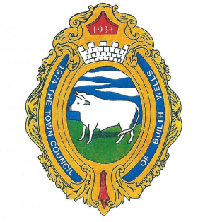

**BUILTH WELLS TOWN COUNCIL**

**CYNGOR TREF LLANFAIR-YM-MUALLT**

**Mayor:** Councillor Gwyn Davies

**Town Clerk:** Louise Hammond

**Biodiversity Project – Overview & Update November 2020**

Builth Wells is very lucky in that it has a wealth of natural beauty, being mainly rural and nestling on the Wye. We are fortunate enough to support many different species of wildlife, along with fauna and flora. We have a mixture of trees, including semi-natural broad-leaved woodland and parkland trees. Along the Groe area (runs adjacent to the river Wye) we have at least 3 species of bat (Natters, Daubenton’s and Noctule). Otter, Badger and Hedgehogs are also found here, as are Kingfishers, Dippers, Heron, and varieties of Duck and Geese. Our stretch of the Wye is noted for the Atlantic Salmon, Brown Trout and Twaite Shad, as well as for the river-jelly lichen.

Last year, in order to support the aspirations and goals of the Welsh Governments Bee Friendly Scheme, we started work on our Bee and Butterfly garden. We identified a small area of unused land close to the River Wye, which was being used as a dumping ground for dog waste bags and other items as being suitable to be the perfect place to start work on our project, as it would also enhance the beauty of this area. We began by clearing the area as much as possible, including the removal of a few dying Ash trees, then started to clear away the rubbish and mess which had been left over a number of years. This was done by Town Councillors and Community Volunteers; the area was then fenced off in a manner that was in keeping with the surrounding environment.

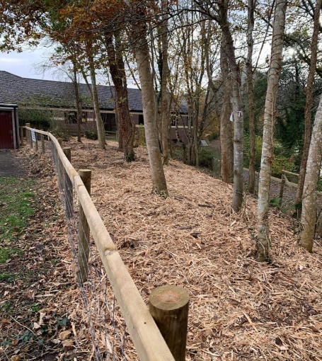 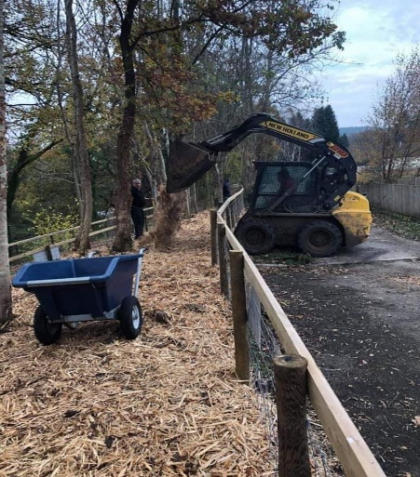 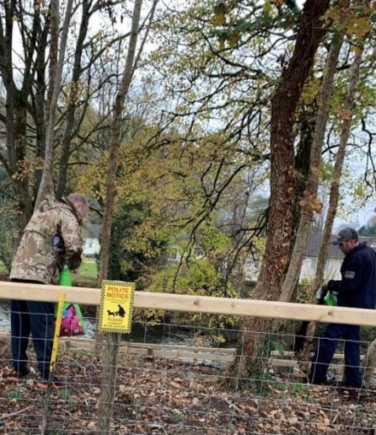

After we had cleared this parcel of land, we spread around 1000 litres of multi-purpose organic compost over it & then added a couple of tonnes of natural bark. The intention is to let this bed-in over the winter and then plant a large number of different Pollinator-friendly flowers & plants to attract the Bee’s and Butterflies back. We hope it will also be a great space for the Community, and visitors to the area, to be able to go and view.

We have estimated that this will take two to three years to fully grow and bed in. It will be regularly monitored by the Council, with any necessary steps being discussed and actioned where agreed, in order to make it a successful project well into the future.

**Louise Hammond**

**Town Clerk**